**TY CSE AY-2022-23 Sem-I**

**Artificial Intelligence and Machine Learning Lab**

**Assignment No 4 Due date- 25/09/2022**

1. Consider the Blocks World Problem given below. Using Goal Stack Planning
2. Elaborate the operations required to achieve goal state.
3. Implement the problem using python to achieve goal.

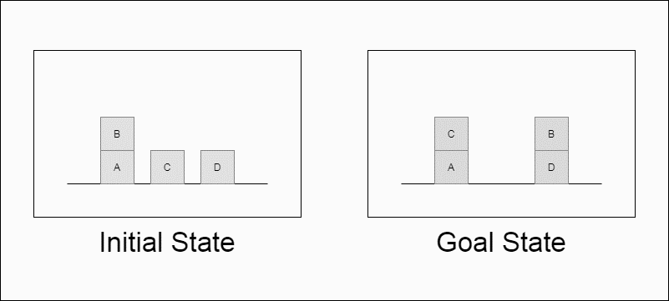

a.

We work backwards from the goal, looking for an operator which has one or more of the goal literals as one of its eﬀects and then trying to satisfy the preconditions of the operator. - The preconditions of the operator become subgoals that must be satisﬁed.We keep doing this unti lwe reach the initial state. Goal stack planning uses a stack to hold goals and actions to satisfy the goals, and a knowledge base to hold the current state,action schemas and domain axioms - Goal stack is like a node in a search tree; if there is a choice of action,we create branches

Goal stack planning pseudocode :

Push the original goal on the stack.Repeat until the stack is empty: - If stack top is a compound goal, push its unsatisﬁed subgoals on the stack. - If stack top is a single unsatisﬁed goal,replace it by an action that makes it satisﬁed and push the action’s precondition on the stack. - If stack top is an action, pop it from the stack, execute it and change the knowledge base by the action’s effects. - If stack top is a satisﬁed goal, pop it from the stack.

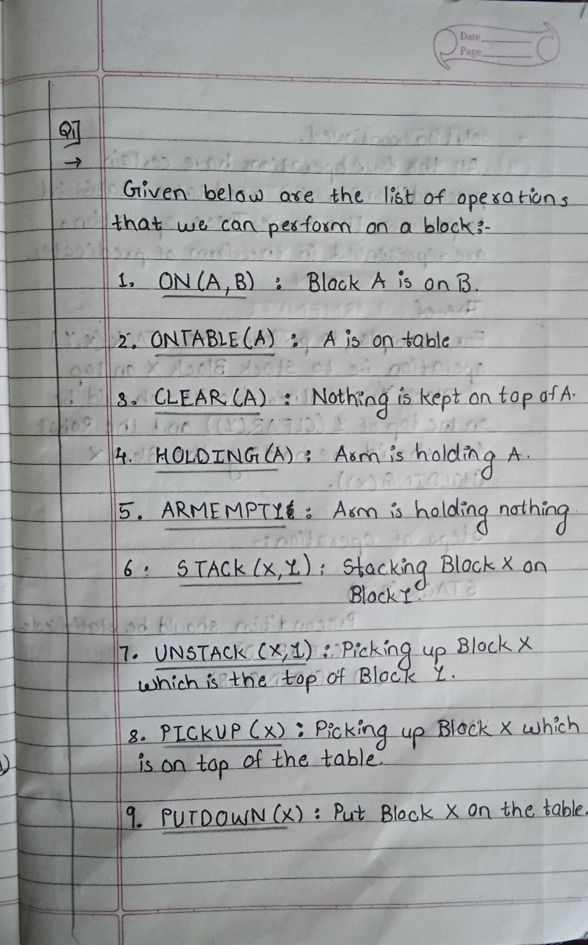

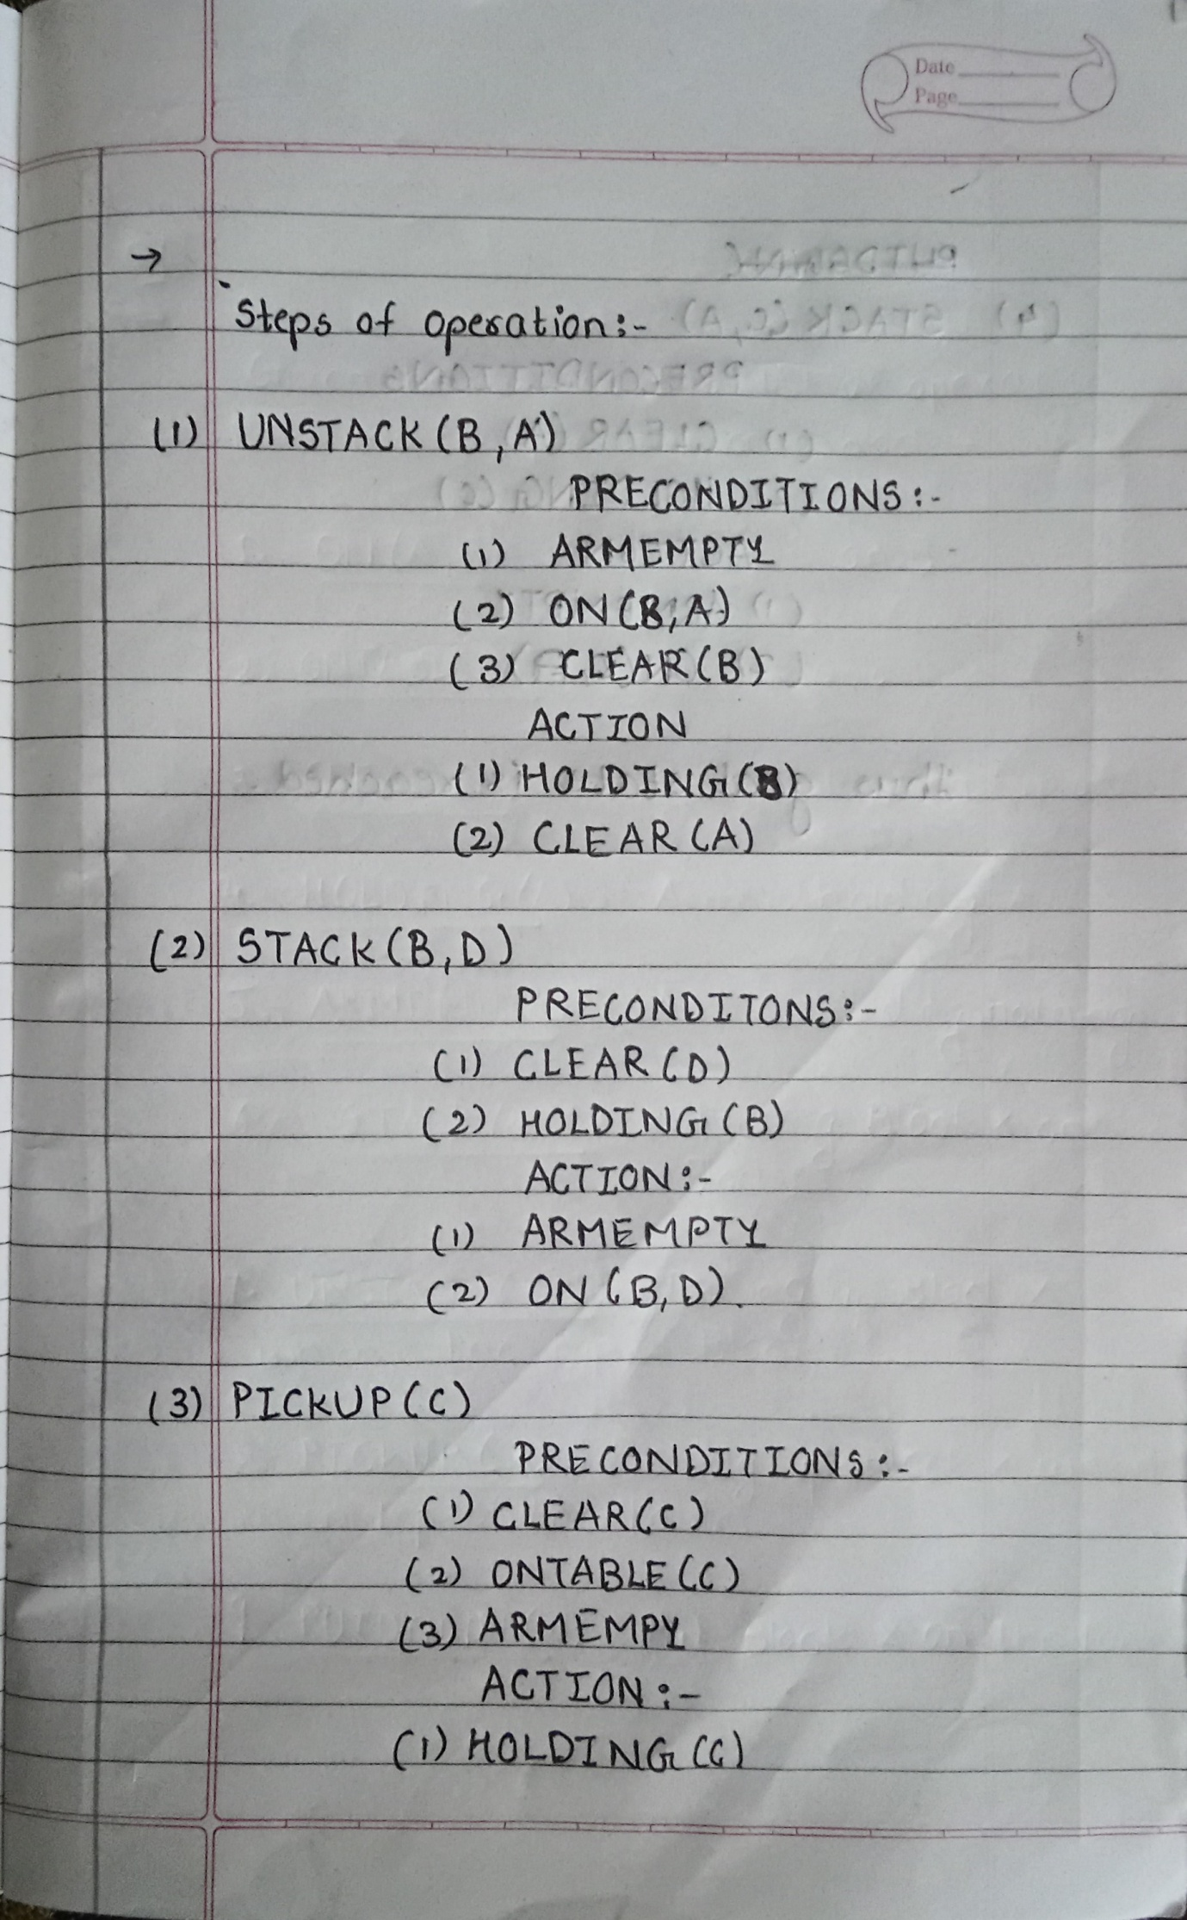

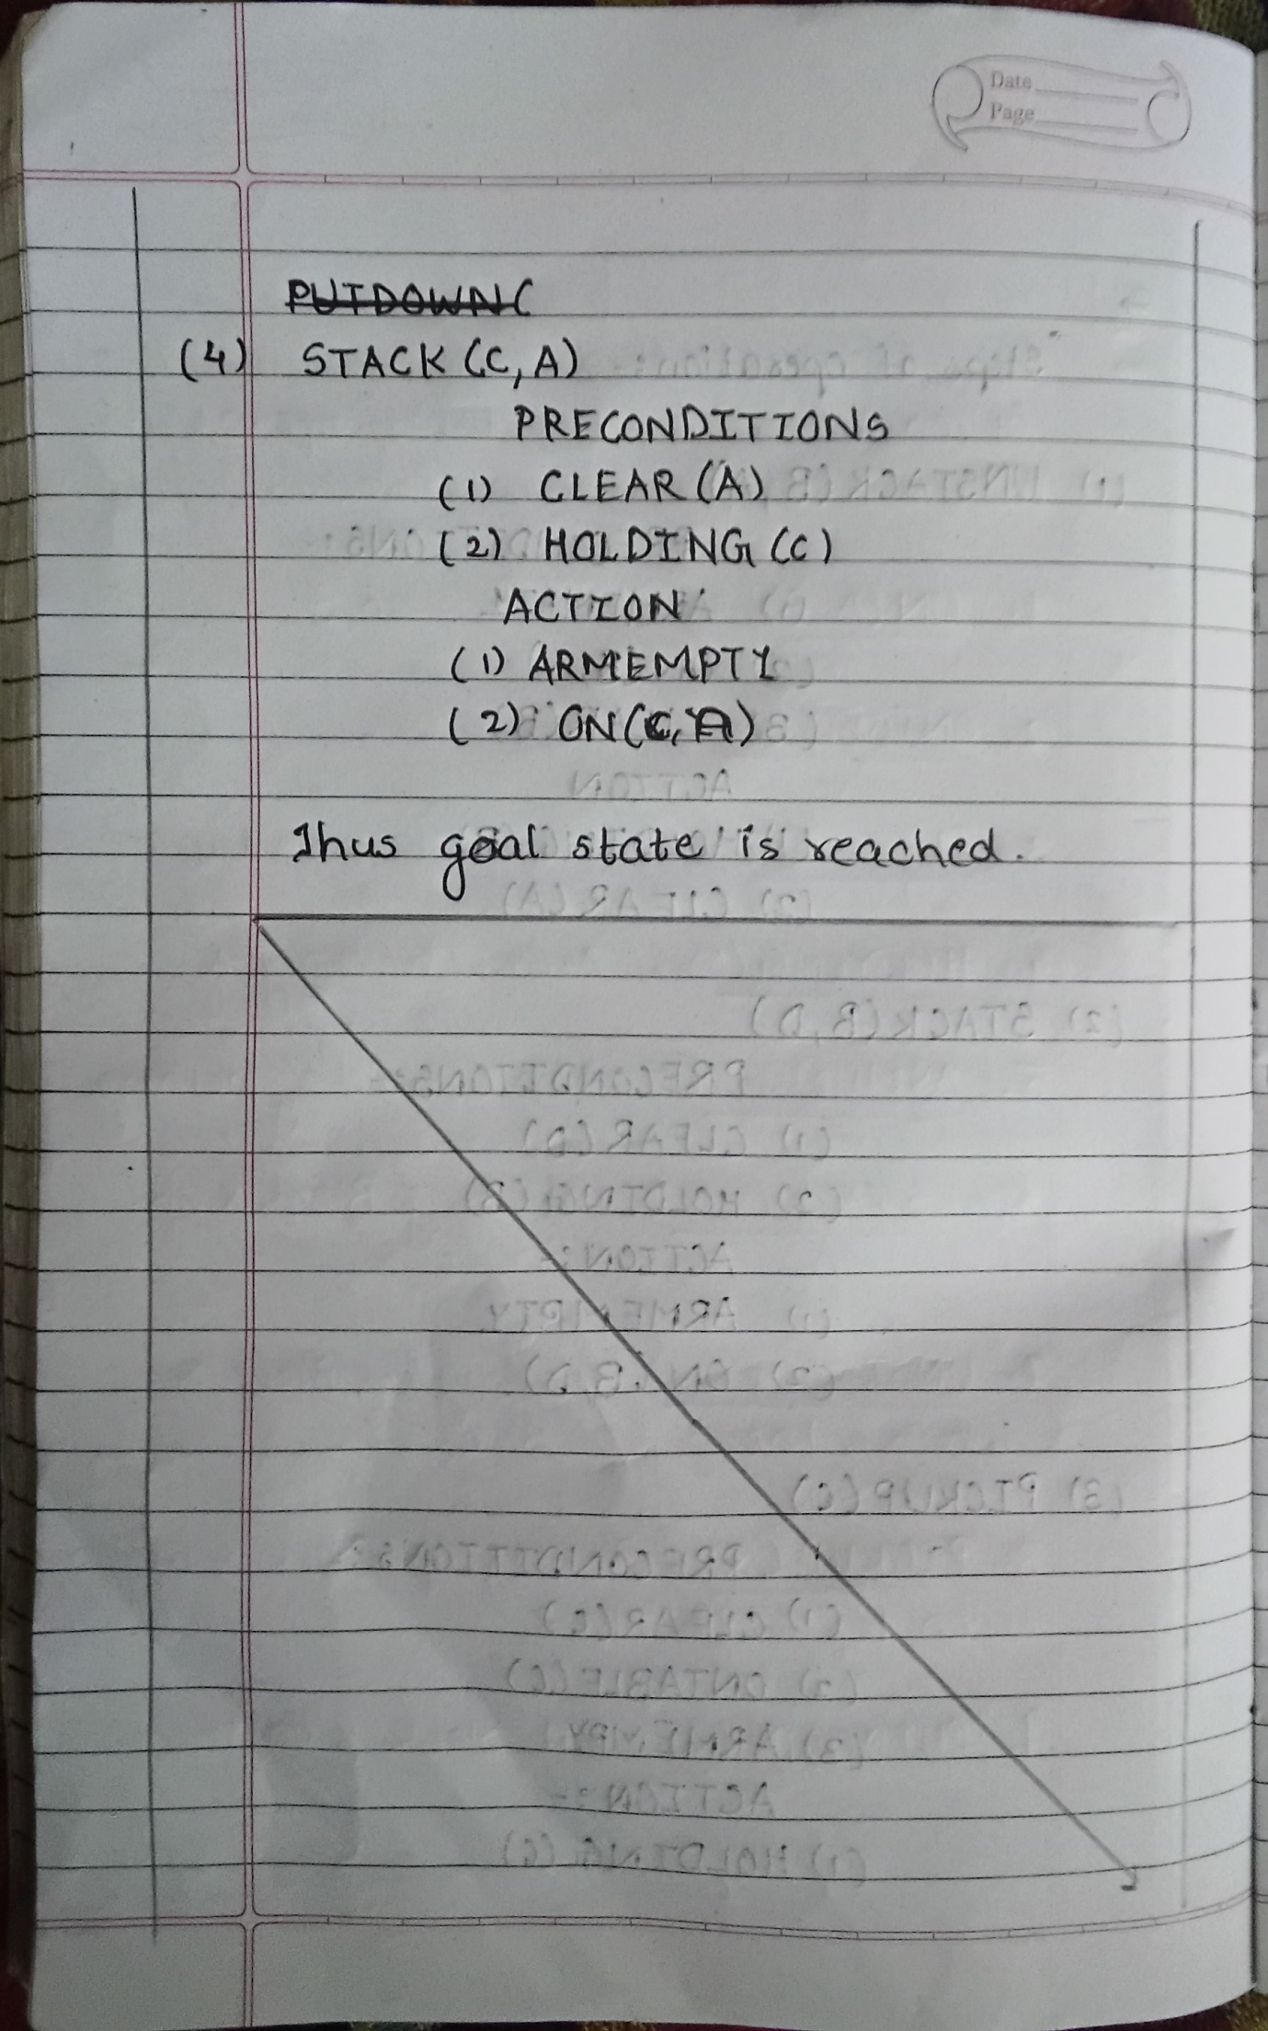

b.

*#Base Classes*

*#PREDICATE - ON, ONTABLE, CLEAR, HOLDING, ARMEMPTY*

class PREDICATE:

  def __str__(self):

    pass

  def __repr__(self):

    pass

  def __eq__(self, other) :

    pass

  def __hash__(self):

    pass

  def get_action(self, world_state):

    pass

*#OPERATIONS - Stack, Unstack, Pickup, Putdown*

class Operation:

  def __str__(self):

    pass

  def __repr__(self):

    pass

  def __eq__(self, other) :

    pass

  def precondition(self):

    pass

  def delete(self):

    pass

  def add(self):

    pass

class ON(PREDICATE):

  def __init__(self, X, Y):

*self*.X = X

*self*.Y = Y

  def __str__(self):

    return "ON({X},{Y})".format(X=*self*.X,Y=*self*.Y)

  def __repr__(self):

    return *self*.__str__()

  def __eq__(self, other) :

    return *self*.__dict__ == other.__dict__ and *self*.__class__ == other.__class__

  def __hash__(self):

      return hash(str(*self*))

  def get_action(self, world_state):

    return StackOp(*self*.X,*self*.Y)

class ONTABLE(PREDICATE):

  def __init__(self, X):

*self*.X = X

  def __str__(self):

    return "ONTABLE({X})".format(X=*self*.X)

  def __repr__(self):

    return *self*.__str__()

  def __eq__(self, other) :

    return *self*.__dict__ == other.__dict__ and *self*.__class__ == other.__class__

  def __hash__(self):

      return hash(str(*self*))

  def get_action(self, world_state):

    return PutdownOp(*self*.X)

class CLEAR(PREDICATE):

  def __init__(self, X):

*self*.X = X

  def __str__(self):

    return "CLEAR({X})".format(X=*self*.X)

*self*.X = X

  def __repr__(self):

    return *self*.__str__()

  def __eq__(self, other) :

    return *self*.__dict__ == other.__dict__ and *self*.__class__ == other.__class__

  def __hash__(self):

    return hash(str(*self*))

  def get_action(self, world_state):

    for predicate in world_state:

*#If Block is on another block, unstack*

      if isinstance(predicate,ON) and predicate.Y==*self*.X:

        return UnstackOp(predicate.X, predicate.Y)

    return None

class HOLDING(PREDICATE):

  def __init__(self, X):

*self*.X = X

  def __str__(self):

    return "HOLDING({X})".format(X=*self*.X)

  def __repr__(self):

    return *self*.__str__()

  def __eq__(self, other) :

    return *self*.__dict__ == other.__dict__ and *self*.__class__ == other.__class__

  def __hash__(self):

    return hash(str(*self*))

  def get_action(self, world_state):

    X = *self*.X

*#If block is on table, pick up*

    if ONTABLE(X) in world_state:

      return PickupOp(X)

*#If block is on another block, unstack*

    else:

      for predicate in world_state:

        if isinstance(predicate,ON) and predicate.X==X:

          return UnstackOp(X,predicate.Y)

class ARMEMPTY(PREDICATE):

  def __init__(self):

    pass

  def __str__(self):

    return "ARMEMPTY"

  def __repr__(self):

    return *self*.__str__()

  def __eq__(self, other) :

    return *self*.__dict__ == other.__dict__ and *self*.__class__ == other.__class__

  def __hash__(self):

    return hash(str(*self*))

  def get_action(self, world_state=[]):

    for predicate in world_state:

      if isinstance(predicate,HOLDING):

        return PutdownOp(predicate.X)

    return None

class StackOp(Operation):

  def __init__(self, X, Y):

*self*.X = X

*self*.Y = Y

  def __str__(self):

    return "STACK({X},{Y})".format(X=*self*.X,Y=*self*.Y)

  def __repr__(self):

    return *self*.__str__()

  def __eq__(self, other) :

    return *self*.__dict__ == other.__dict__ and *self*.__class__ == other.__class__

  def precondition(self):

    return [ CLEAR(*self*.Y) , HOLDING(*self*.X) ]

  def delete(self):

    return [ CLEAR(*self*.Y) , HOLDING(*self*.X) ]

  def add(self):

    return [ ARMEMPTY() , ON(*self*.X,*self*.Y) ]

class UnstackOp(Operation):

  def __init__(self, X, Y):

*self*.X = X

*self*.Y = Y

  def __str__(self):

    return "UNSTACK({X},{Y})".format(X=*self*.X,Y=*self*.Y)

  def __repr__(self):

    return *self*.__str__()

  def __eq__(self, other) :

    return *self*.__dict__ == other.__dict__ and *self*.__class__ == other.__class__

  def precondition(self):

    return [ ARMEMPTY() , ON(*self*.X,*self*.Y) , CLEAR(*self*.X) ]

  def delete(self):

    return [ ARMEMPTY() , ON(*self*.X,*self*.Y) ]

  def add(self):

    return [ CLEAR(*self*.Y) , HOLDING(*self*.X) ]

class PickupOp(Operation):

  def __init__(self, X):

*self*.X = X

  def __str__(self):

    return "PICKUP({X})".format(X=*self*.X)

  def __repr__(self):

    return *self*.__str__()

  def __eq__(self, other) :

    return *self*.__dict__ == other.__dict__ and *self*.__class__ == other.__class__

  def precondition(self):

    return [ CLEAR(*self*.X) , ONTABLE(*self*.X) , ARMEMPTY() ]

  def delete(self):

    return [ ARMEMPTY() , ONTABLE(*self*.X) ]

  def add(self):

    return [ HOLDING(*self*.X) ]

class PutdownOp(Operation):

  def __init__(self, X):

*self*.X = X

  def __str__(self):

    return "PUTDOWN({X})".format(X=*self*.X)

  def __repr__(self):

    return *self*.__str__()

  def __eq__(self, other) :

    return *self*.__dict__ == other.__dict__ and *self*.__class__ == other.__class__

  def precondition(self):

    return [ HOLDING(*self*.X) ]

  def delete(self):

    return [ HOLDING(*self*.X) ]

  def add(self):

    return [ ARMEMPTY() , ONTABLE(*self*.X) ]

def isPredicate(obj):

  predicates = [ON, ONTABLE, CLEAR, HOLDING, ARMEMPTY]

  for predicate in predicates:

    if isinstance(obj,predicate):

      return True

  return False

def isOperation(obj):

  operations = [StackOp, UnstackOp, PickupOp, PutdownOp]

  for operation in operations:

    if isinstance(obj,operation):

      return True

  return False

def arm_status(world_state):

  for predicate in world_state:

    if isinstance(predicate, HOLDING):

      return predicate

  return ARMEMPTY()

class GoalStackPlanner:

  def __init__(self, initial_state, goal_state):

*self*.initial_state = initial_state

*self*.goal_state = goal_state

  def get_steps(self):

*#Store Steps*

    steps = []

*#Program Stack*

    stack = []

*#World State/Knowledge Base*

    world_state = *self*.initial_state.copy()

*#Initially push the goal_state as compound goal onto the stack*

    stack.append(*self*.goal_state.copy())

*#Repeat until the stack is empty*

    while len(stack)!=0:

*#Get the top of the stack*

      stack_top = stack[-1]

*#If Stack Top is Compound Goal, push its unsatisfied goals onto stack*

      if type(stack_top) is list:

        compound_goal = stack.pop()

        for goal in compound_goal:

          if goal not in world_state:

            stack.append(goal)

*#If Stack Top is an action*

      elif isOperation(stack_top):

*#Peek the operation*

        operation = stack[-1]

        all_preconditions_satisfied = True

*#Check if any precondition is unsatisfied and push it onto program stack*

        for predicate in operation.delete():

          if predicate not in world_state:

            all_preconditions_satisfied = False

            stack.append(predicate)

*#If all preconditions are satisfied, pop operation from stack and execute it*

        if all_preconditions_satisfied:

          stack.pop()

          steps.append(operation)

          for predicate in operation.delete():

            world_state.remove(predicate)

          for predicate in operation.add():

            world_state.append(predicate)

*#If Stack Top is a single satisfied goal*

      elif stack_top in world_state:

        stack.pop()

*#If Stack Top is a single unsatisfied goal*

      else:

        unsatisfied_goal = stack.pop()

*#Replace Unsatisfied Goal with an action that can complete it*

        action = unsatisfied_goal.get_action(world_state)

        stack.append(action)

*#Push Precondition on the stack*

        for predicate in action.precondition():

          if predicate not in world_state:

            stack.append(predicate)

    return steps

if __name__ == '__main__':

  initial_state = [

    ON('B','A'),

    ONTABLE('A'),ONTABLE('C'),ONTABLE('D'),

    CLEAR('B'),CLEAR('C'),CLEAR('D'),

    ARMEMPTY()

  ]

  goal_state = [

    ON('B','D'),ON('C','A'),

    ONTABLE('D'),ONTABLE('A'),

    CLEAR('B'),CLEAR('C'),

    ARMEMPTY()

  ]

  goal_stack = GoalStackPlanner(initial_state=initial_state, goal_state=goal_state)

  steps = goal_stack.get_steps()

  print(steps)

1. Having to plan a trip, say from Chennai to Jaipur, the first thing one might to do is to find suitable train and/or flight combinations between the two cities, and then fill in all the other actions. What kind of planning will allow one to do so?

 